Loop/Repetition Statements

Lecture 4 Assignments

1. What is the output of the following program?

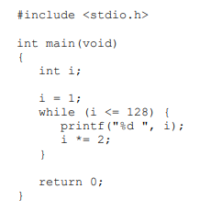

Source code (as1.c):

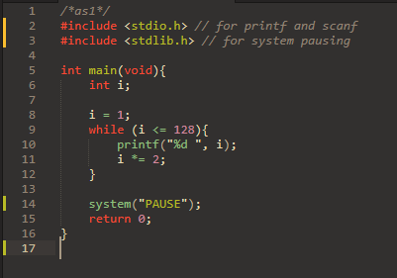

Output:

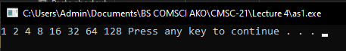

Answer: The output is the sequence of incrementing value of i = 1, as it is multiplied to 2 until the number exceeds 128.

1. Which one of the following statements is not equivalent to the other two (assuming that the loop bodies are the same)?

Answer:

The first two kinds of loop are more equivalent to each other compared to the third, which is the do loop. It is because the first two types of loops might have their conditional expression to not let their loop body to execute at all. While in the third type (do loop), the loop will be executed first, the condition of which will be checked last. Moreover, the while loop is equivalent to that of a for loop, which has no update and initializing parameter (left only with its expression as the only parameter).

Source code (as2.c):

In this code, I used 10 as the value of i, which did not let the body of while and for loop be executed. Only the do loop was successful in executing its statement/s

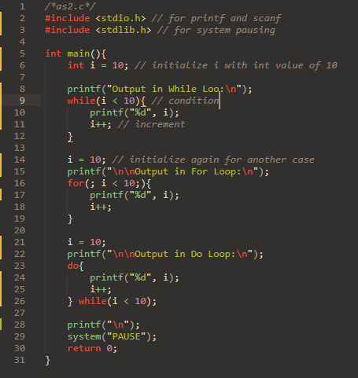

Output:

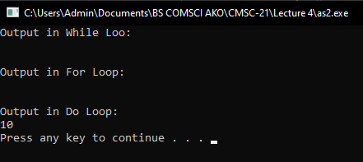

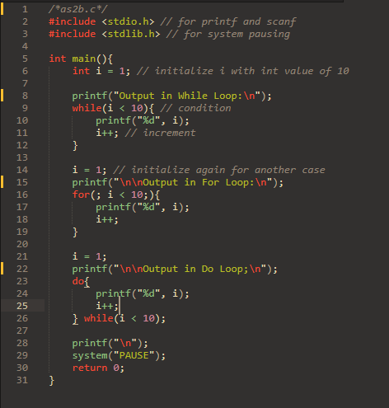If the value of i is equal to 1, then the body of all loops will execute, for all of their conditions are met.

Output:

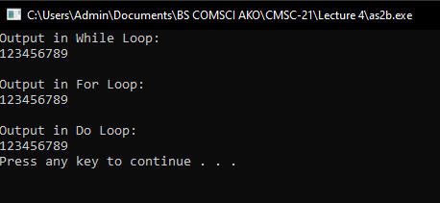

1. Convert item 1 into an equivalent for statement. You can validate your answer by checking if the produced outputs by both the while and for statements are similar.

Source code (as3.c):

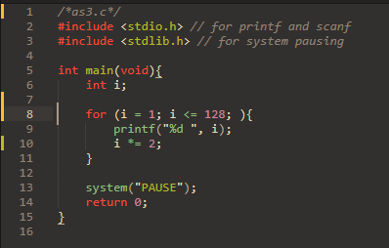

Output:

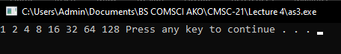

Compared to as1.c:

